Liberty Co Senior Center 759-5244 August 2025
Sunday | Monday | Tuesday | Wednesday | Thursday | Friday |  | Saturday
 |  |  |  |  | 1 |  | 2
Menus are subject to change without notice |  |  |  |  | Crab Quiche, carrots, cinnamon rolls
3 | 4 | 5 | 6 | 7 | 8 |  | 9
 | Hamburger Stroganoff, green beans | BBQ Chicken, mashed potatoes, corn | Cheeseburger soup, egg salad sandwich, strawberry rhubarb pie | Hot Pork Sandwich, mashed potatoes, carrots | Lasagna, garlic toast, capri vegetables |  |   This Photo by Unknown Author is licensed under CC BY-SA-NC
10 | 11 | 12 | 13 | 14 | 15 |  | 16
 | Chicken & Biscuits, peas and carrots | Porcupine Meatballs, mashed potatoes, green beans | Lemon Chicken Orzo Soup, Meatloaf sandwich, Banana Cream Pie | Hamburgers, baked beans, onion rings, let, tom & onion | Pizza
17 | 18 | 19 | 20 | 21 | 22 |  | 23
 | Chicken tenders, tater tots, peas | Meatloaf, mashed potatoes, green beans | Clam Chowder, Tuna sandwich, blueberry pie | Liver & Onions, mashed potatoes, beets | Sloppy Joes, corn
24 | 25 | 26 | 27 | 28 | 29 |  | 30
 | Ham & Scalloped potatoes, broccoli | Roast Turkey, mashed potatoes, carrots | Ham & Bean soup, egg salad sand., cherry pie | Taco Salad Bar | Biscuits & Gravy, peas and carrots
31
 |  |  |  |  |  |  | 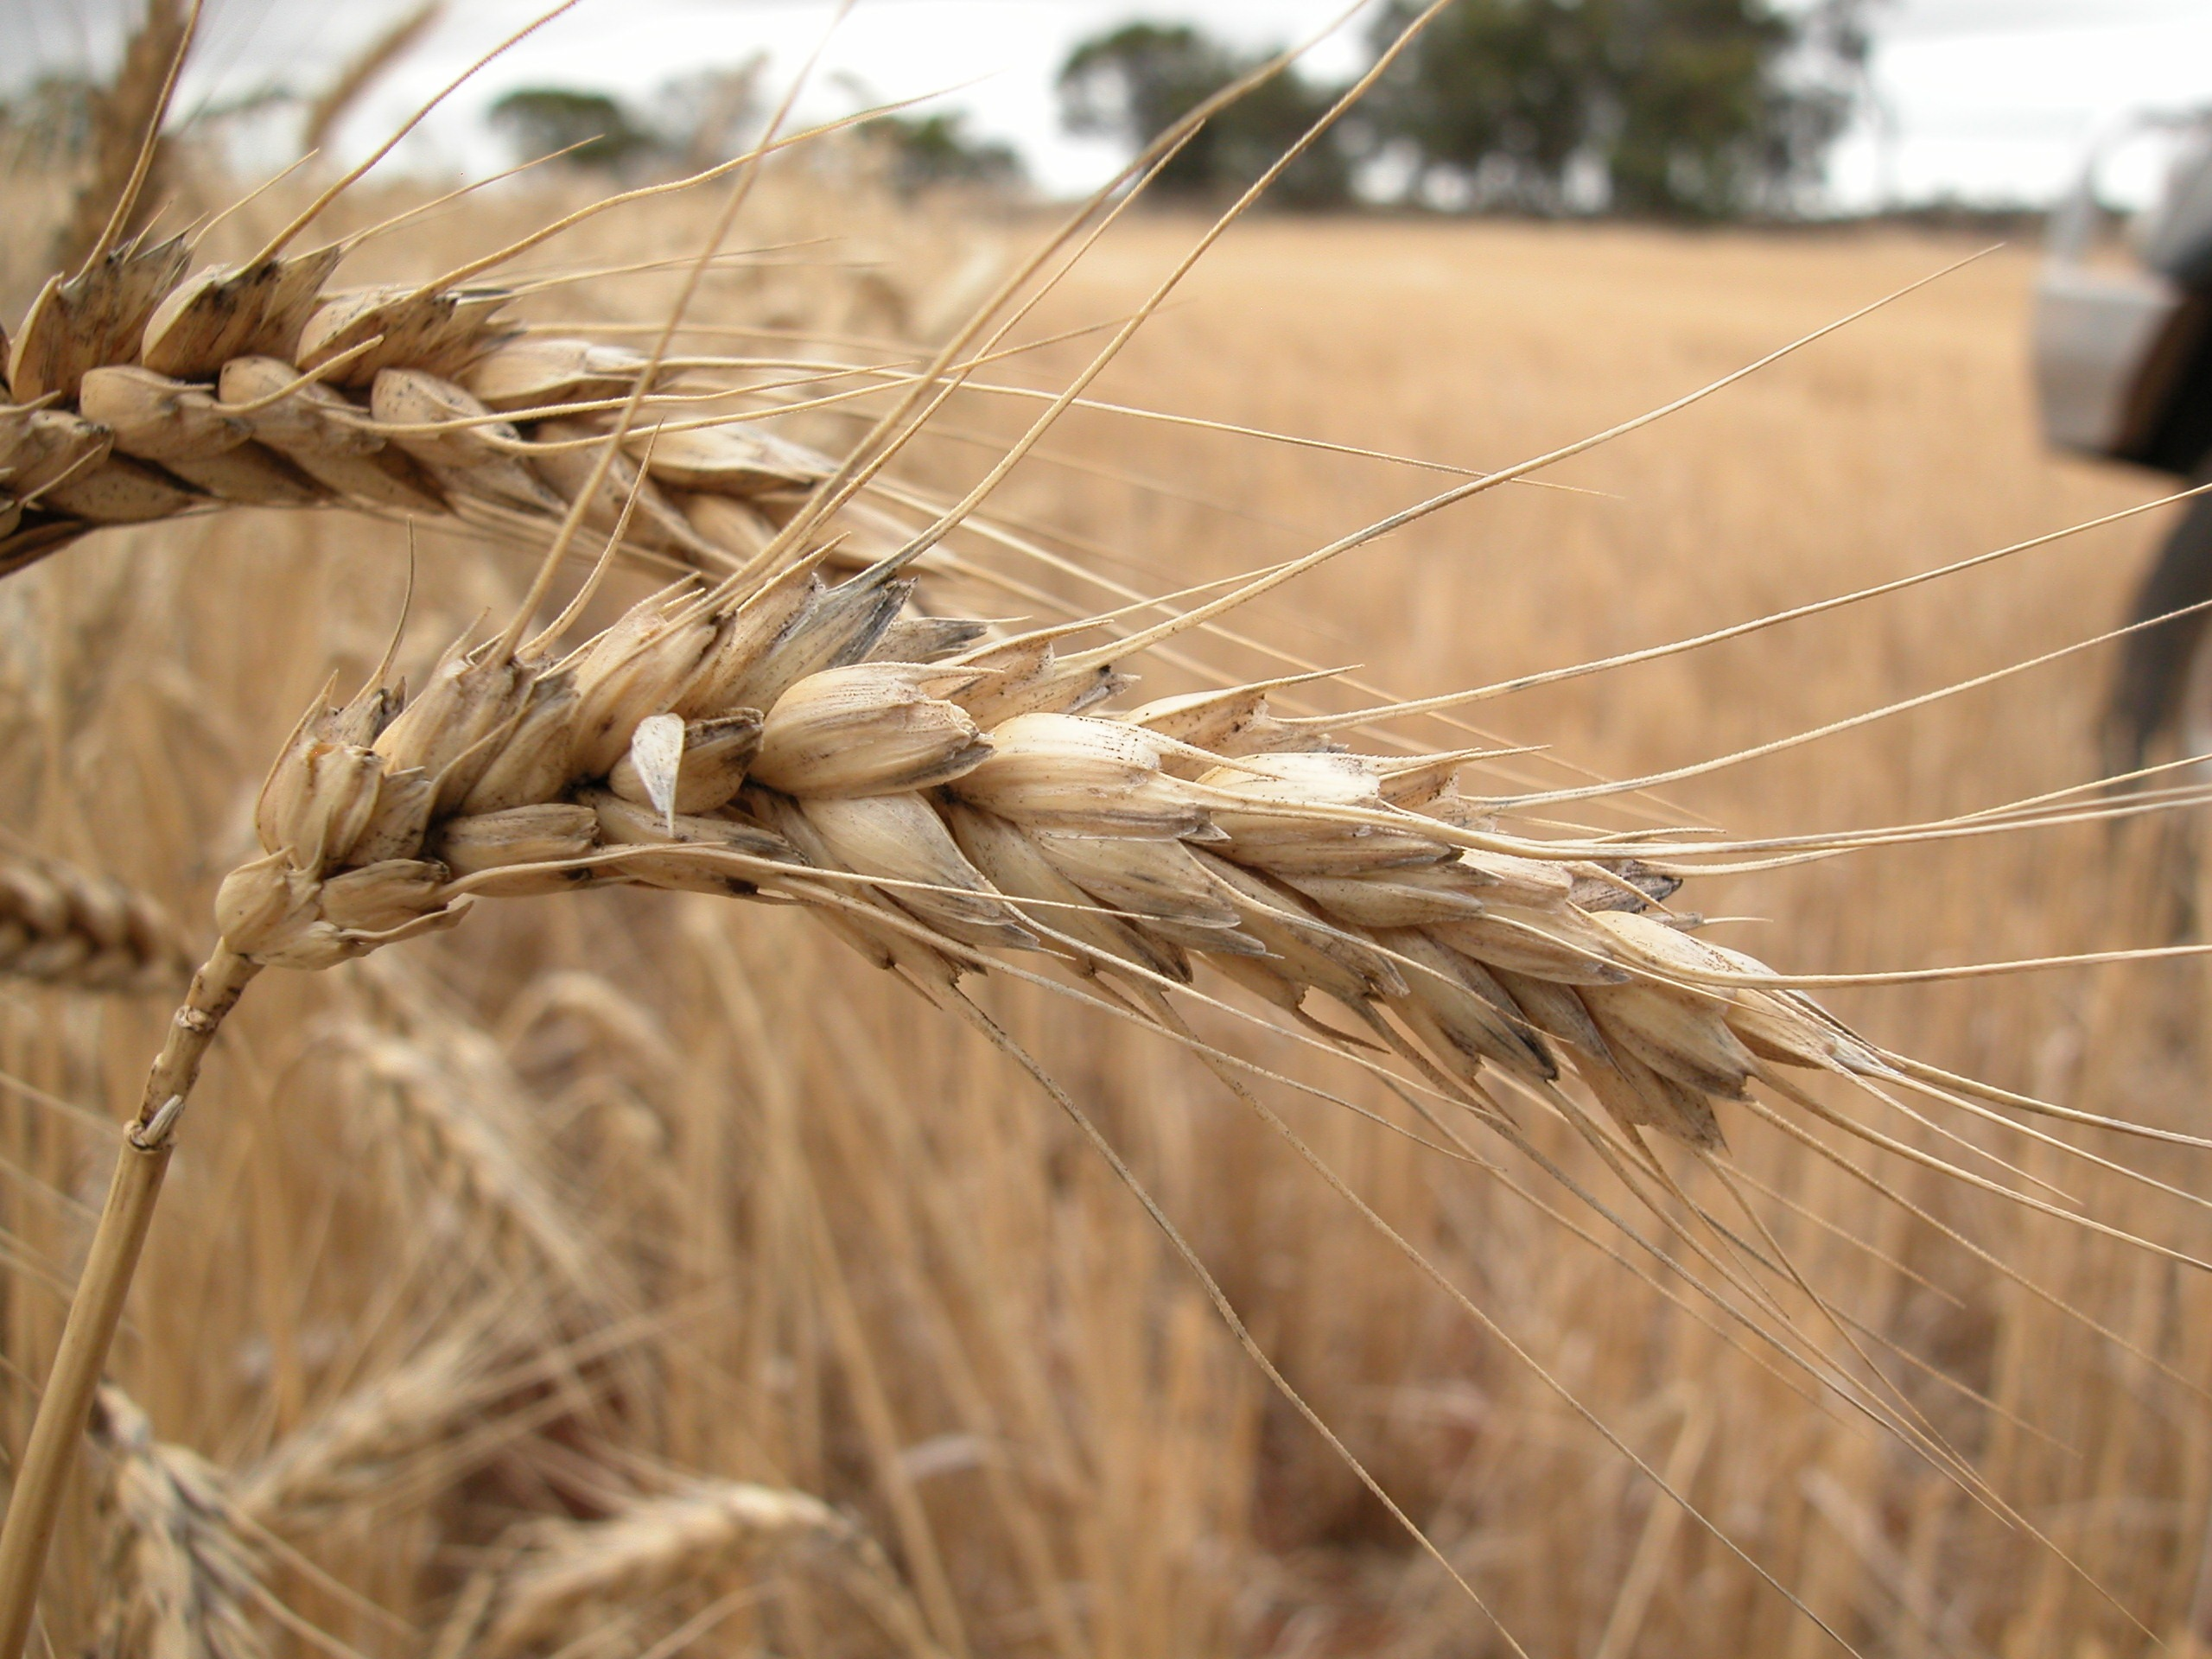
A salad bar with fruit, vegetables and pudding is available with lunch at the Center every serving day. The salad bar is out at approximately 11:30a.m. and the main course is served at noon. Milk is available upon request.
Home Delivered meals are available every serving day. Please call by 10:00a.m. A salad and dessert(fruit) is included. Milk is available if requested. Take-outs may have the salad bar in place of the main Dinner Entrée. Thank you for participating in our meals program and activities.

